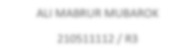

ALI MABRUR MUBAROK

210511112

/ R

3

Nama : ARYA SUBHANDHI

Nim : 210511107

Kelas : TIF21C / R3

1. Overload1.py , Overload2.py Overload1.py =

#Nama : ARYA SUBHANDHI

#Nim : 210511107

#Kelas : TIF21C / R3

print(min(2, 5)) print(min([1, 2, 3])) print(min("football"))

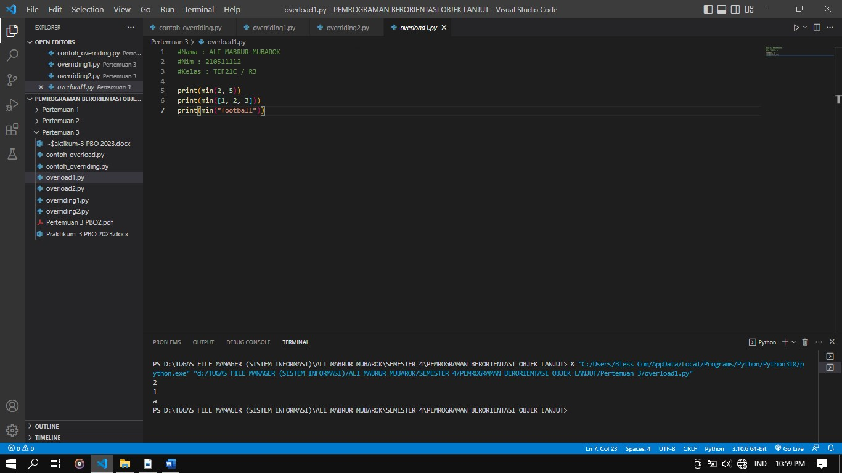

Overload2.py =

#Nama : ALI MABRUR MUBAROK

#Nim : 210511112

#Kelas : TIF21C / R3

b = ["c", 2, "a", 6, "b", "c", 1, 5, 4,"d", 3, "e"]

b.remove(5) print(b)

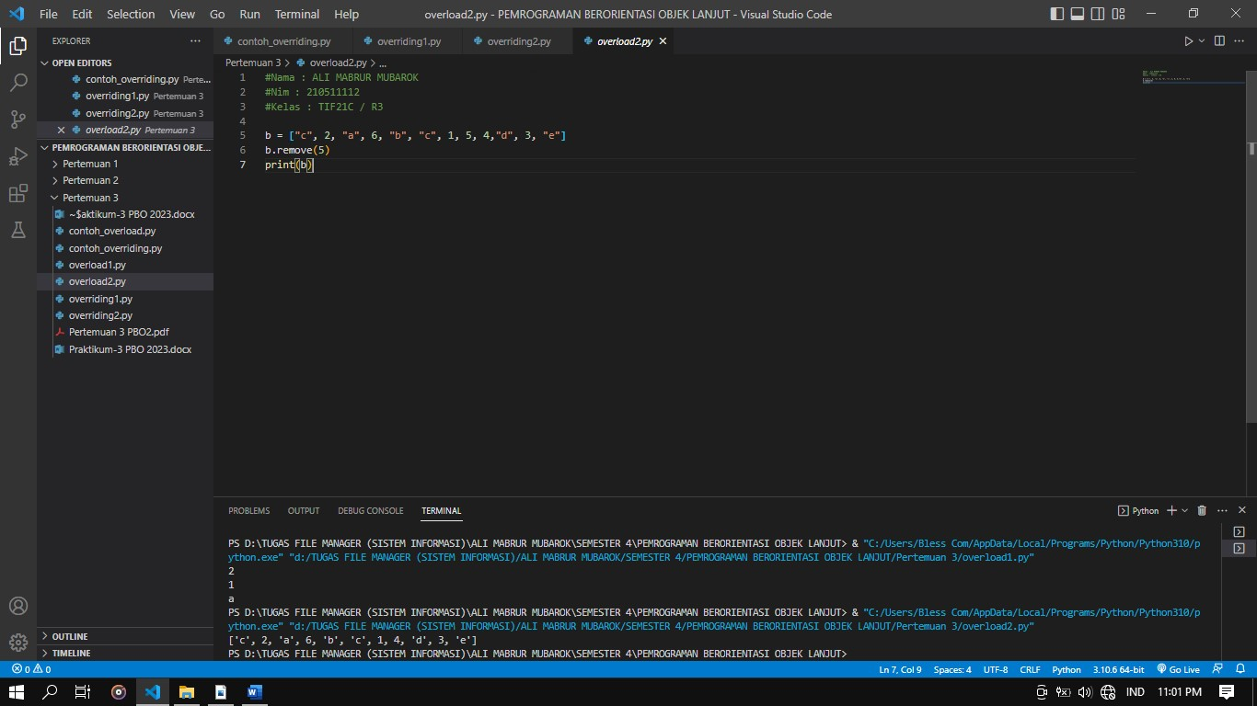

2. Overriding1.py , Overriding2.py

Overriding1.py =

#Nama : ALI MABRUR MUBAROK

#Nim : 210511112

#Kelas : TIF21C / R3

class Hero: def help(self):

print("Hero in here")

class Superman(Hero):

def help(self):

print("Superman is helping you")

class Batman(Hero):

def help(self):

print("Batman in dark is coming to you")

class Ahmad(Superman):

def help(self):

print("Ahmad akan menolongmu")

class Joko(Superman):

def help(self):

print("Joko sang pahlawan kegelapan akan menghampirimu")

def hero_help(hero):

hero.help()

hero = Hero() parman = Superman() batman = Batman() orang1 = Ahmad() orang2 = Joko()

hero_help(hero) hero_help(parman) hero_help(batman) hero_help(orang1) hero_help(orang2)

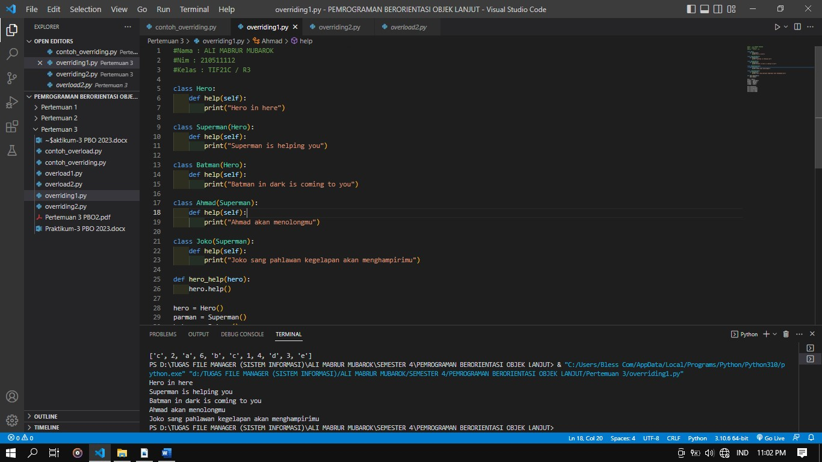

Overriding2.py =

#Nama : ALI MABRUR MUBAROK

#Nim : 210511112

#Kelas : TIF21C / R3

class Suhu: def convert_to_celcius(self):

pass

class Reamur(Suhu): def __init__(self, reamur): self.reamur = reamur

def convert_to_celcius(self): return 5/4 * self.reamur

class Kelvin(Suhu):

def __init__(self, kelvin):

self.kelvin = kelvin

def convert_to_celcius(self):

return self.kelvin - 273

class Fahrenheit(Suhu): def __init__(self, fahren):

self.fahren = fahren

def convert_to_celcius(self): return 5/9 * (self.fahren - 32)

derajat = [Reamur(20), Kelvin(54), Fahrenheit(30)] for suhu in derajat: print(suhu.convert_to_celcius())

